Progress report: time delay constant estimation

Nov. 15, 2017

**Methods tested:**

1. Since the signals we are going to analyse usually have a trend, therefore, finding the frequency of the trend would can be useful for after analysis.
2. Apply the CSD (cross spectral density) and CORR (time correlation based) methods on synthetic data and TE model output data.

**Synthetic Data Simulation Model:**

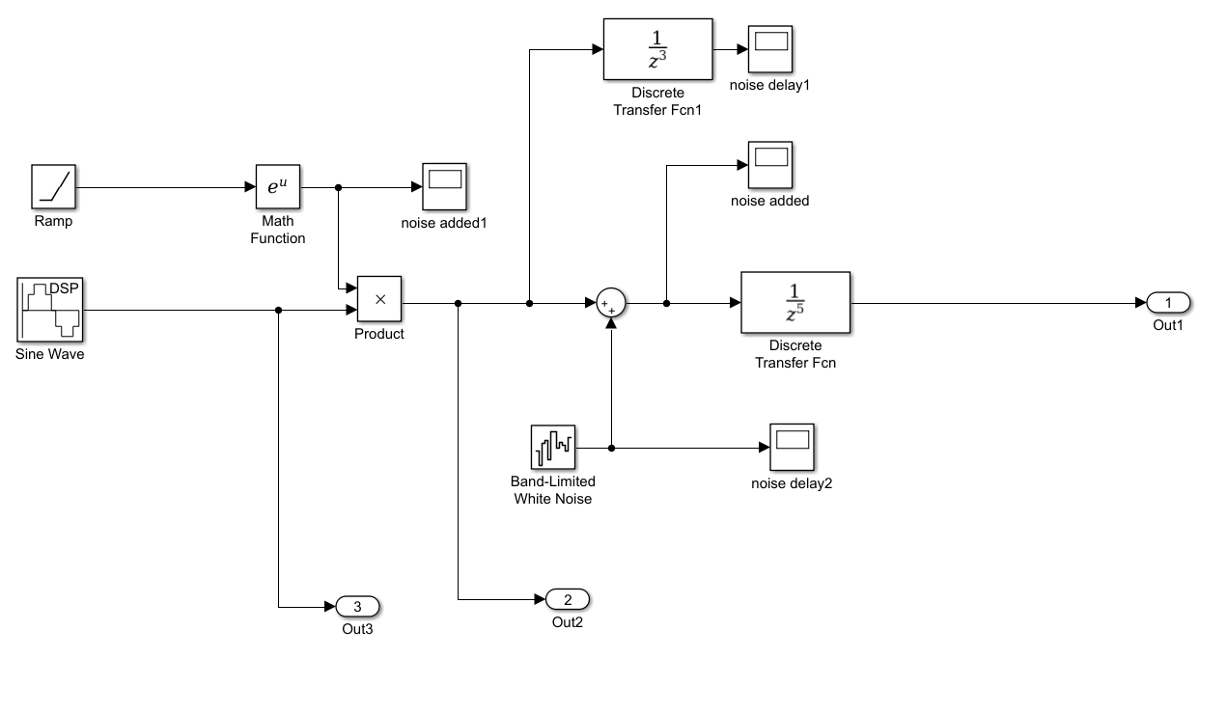

Figure1. Damped and delayed sinusoid

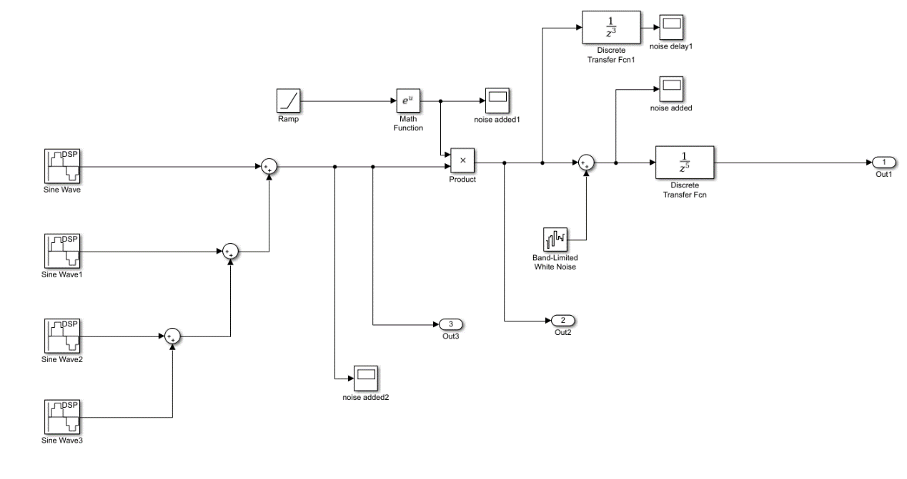

Figure1. multiple delayed sinusoids

**Results:**

1. Find the frequency (for coherence):

Using magnitude squared coherence estimate (MSCE)

a) Apply the MSCE directly on the signal (using matlab function mscohere)

b) The frequency used is where the magnitude squared coherence has the largest or second largest value.

1. Testing
   1. Testing on damping sin and multi sin data
      1. With 0.005s delay inserted

|  |  |  |  |  |
| --- | --- | --- | --- | --- |
|  | Signal Frequency | Frequency calculated | Delay: Correlation | Delay: CSD |
| Damped sin | 10Hz | 9.9975 | 0.005 | 0.0051 |
| 30Hz | 29.9925 | 0.005 | 0.005 |
| 50Hz | 49.9875Hz | 0.005 | 0.0049 |
|  | Frequency set | Frequency calculated | Delay estimate Correlation | Delay estimate CSD |
| Multi sin data | 10Hz | 9.9975 | 0.005 | 0.0051 |
| 30Hz | 29.9925 | 0.005 | 0.0049 |
| 50Hz | 49.9875Hz | 0.005 | 0.005 |

Both methods worked well on the signals we generated with different fundamental frequencies.

* 1. Testing on the TE output signal

There are 15 sets of TE output signals were used for testing. 1s and 0.001s delay was inserted into the signal directly.

Delay calculated on TE data: xmeas 1 2 3 4 7 8 9 10 11 12 14 15 17 23 40

Table 1. Results of Test on TE Data



In the table 1, for the first and third rows, 0.01s delay is inserted, for second and fourth rows the 1s delay is inserted. The first and second rows used the Correlation method and the third and fourth rows used the CSD method. The tests are repeated multiple times. As we can see, most of the time the Correlation method worked well on these signals, and CSD method was way off for the TE signals. One possible reason can be that, these signals have colored noise, and they can have very strong correlations, which affects the CSD calculation.

**Future testing:**

1. Apply the Multivariable Regression model (MAR).

Basically, the MAR is used to find autoregressive(AR) coefficients. Then those AR coefficients will be transferred into frequency domain and use the AR coefficients in frequency domain to estimate the series’ coherence.  Then we are able to apply the previous coherence method to find the delay time.